I wish that he would pay me.

I wish that i could buy me that chair.

I wish that i were good playing basketball.

She wishes she good luck in her examen.

chocaste mi carro

debes pagarme

I’m so sorry about damaging..

Oh, that’s OK

I’m sorry. It was an accident.

I’m not famous.

i wish that i were famous.

I’m broke.

i wish that i had a lot of money .

I have to work on the weekend.

I wish that i hadnt to work on the weekend.

1 clothes and cars

2 a lot of invests

3 budget spend make

4 90% give

they libve soouthern africa

Greece

singing

i think that invest my money knowledge

both relationaned with the drugs

the monks sing song about the drugs so they ear some money.

the sotutheern african people earn some money

using the medicine plants .

I think they don't hurt nobody of this way.

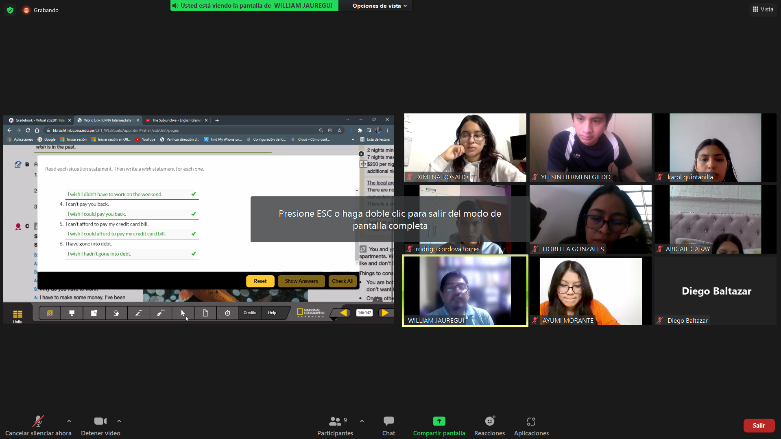

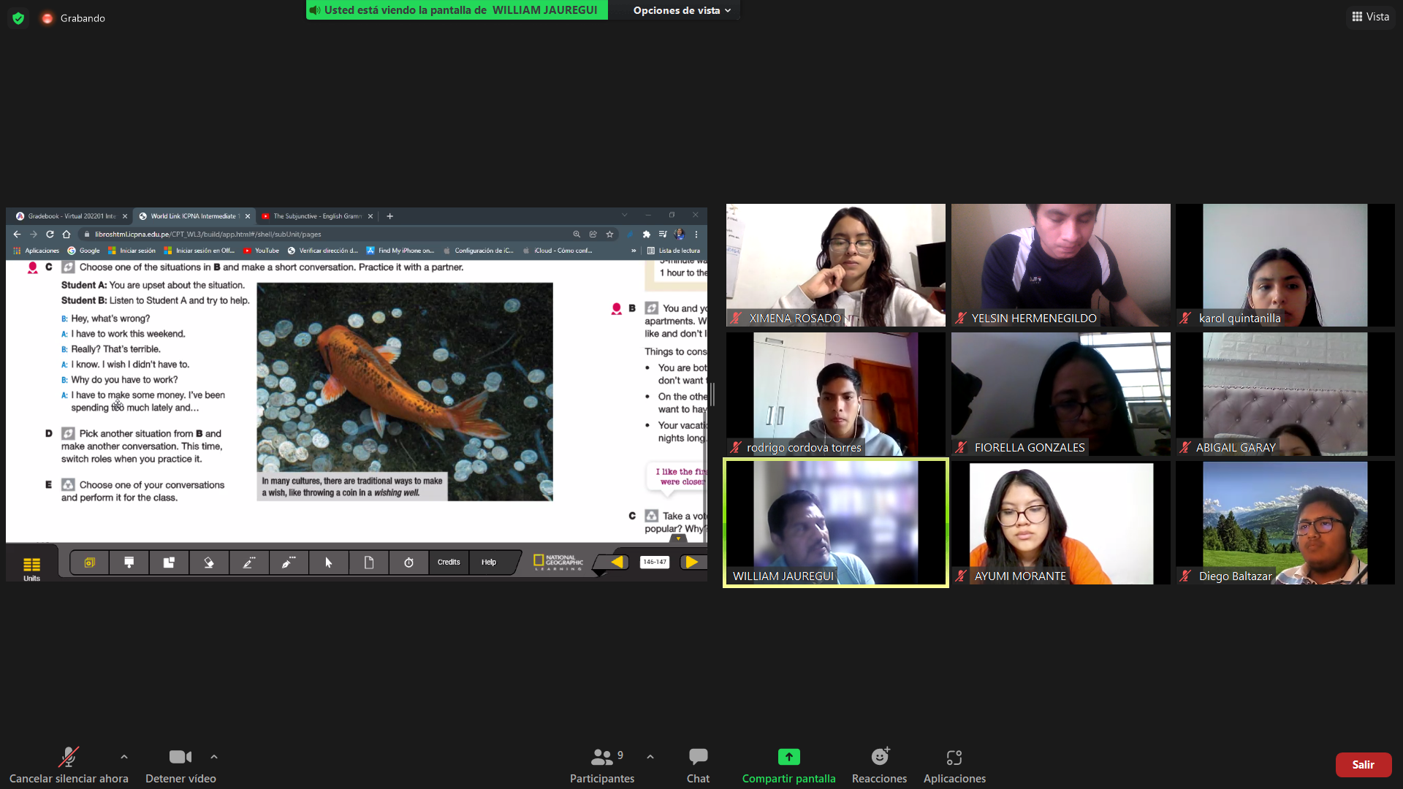

the next week im going to the beach and and I have no one to go with

.I wish that you could go the beach with me.but if you will be busy not problem.

maybe ,the other day i wish that you acompany me.

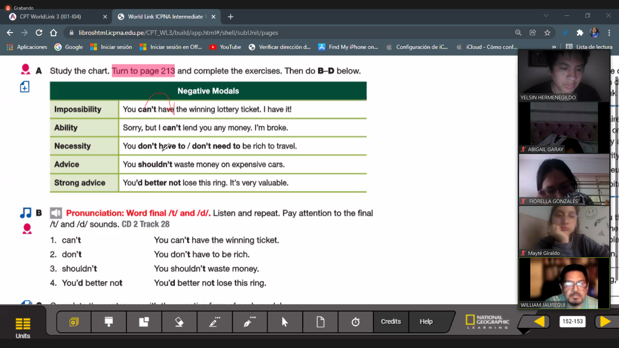

Got into->se metio en

Dented->daño

##1

conversation

1. Carlos fail his examen

2.why

3. because he cheated on it to himself, he don't studied

4.dasds

#2

1. Jose didnt get a ticket for the bonjovi concert .

2.why

3. his dad caught spending the money of the concert.

4.

#3

1.

2.why what happened?

3.

4.sorry hear that.

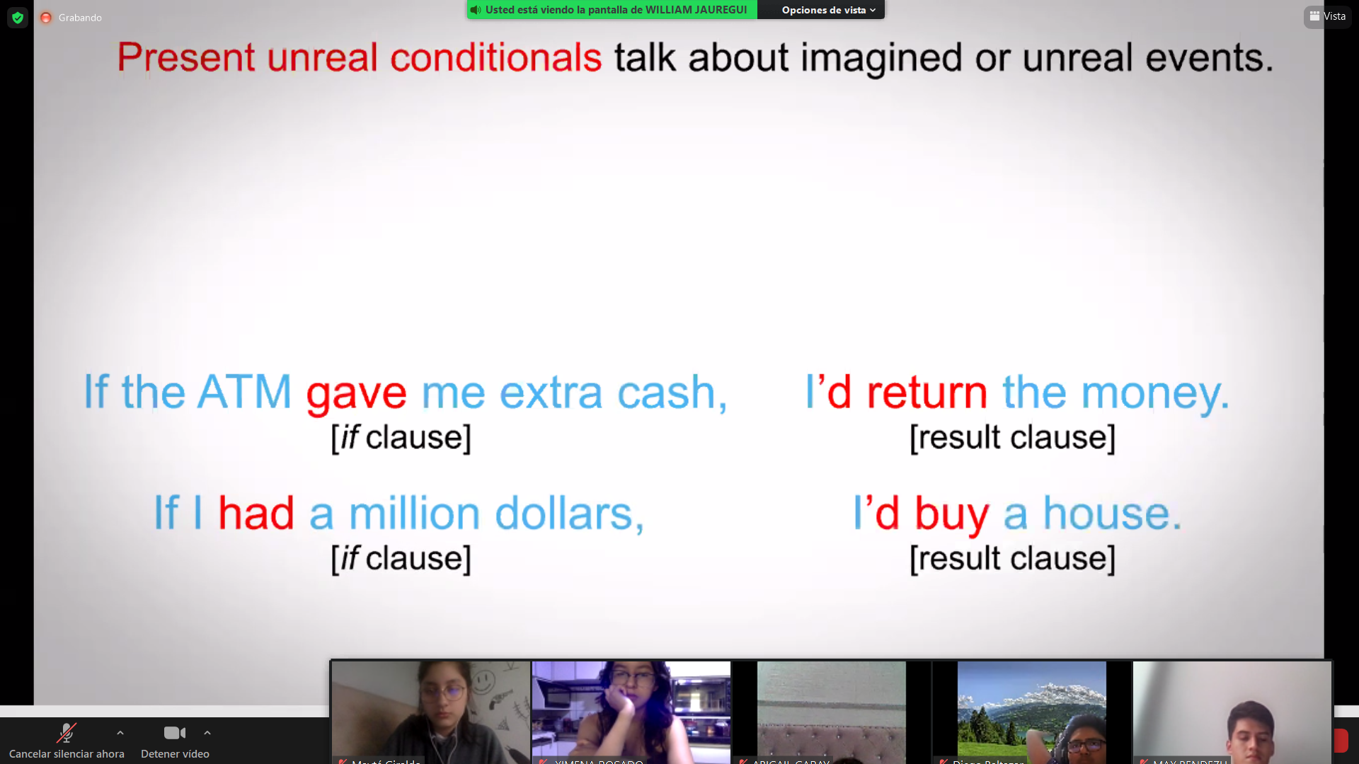

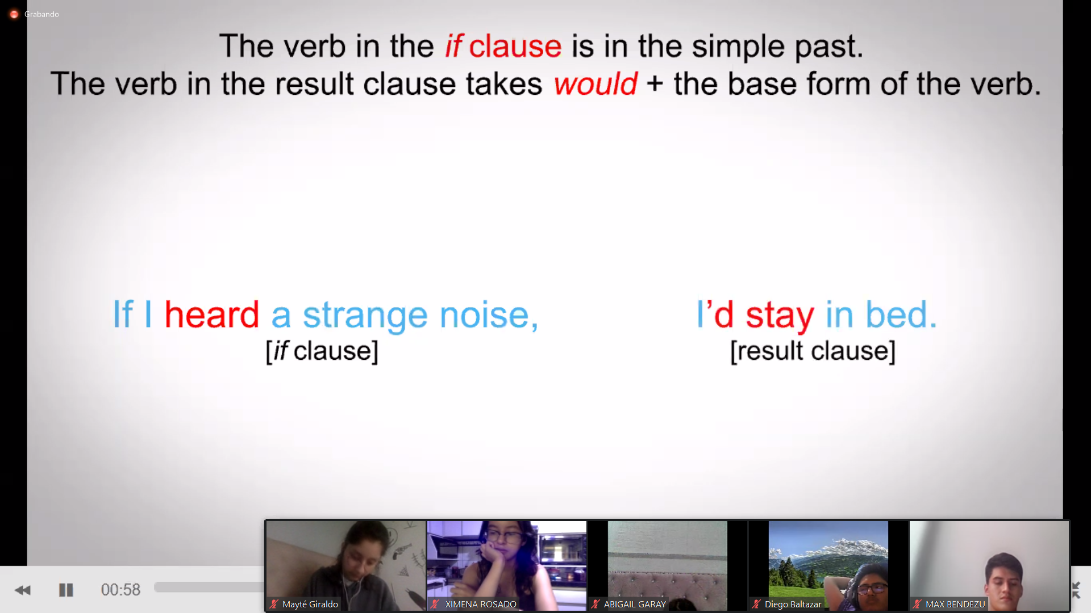

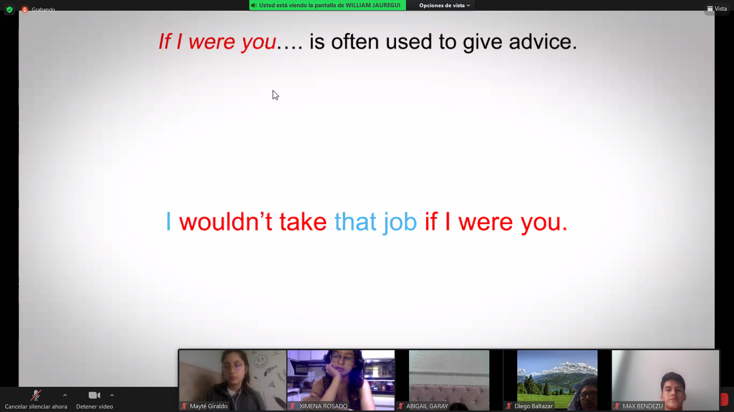

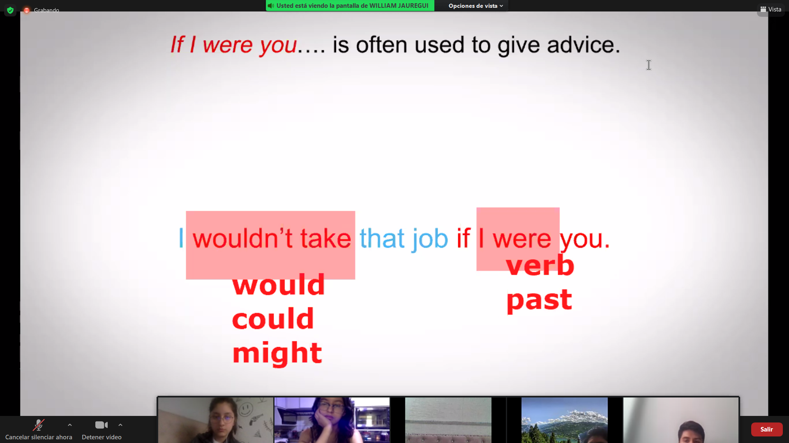

Hellos here is the Bill of your food

Whats wrong

you have tip the waiter

i dont think i should leave tip because im saving

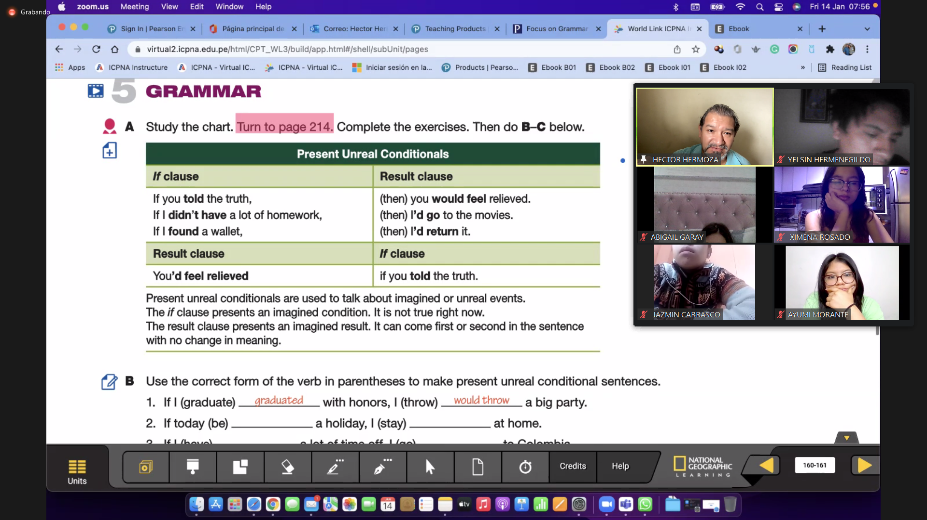

Subject and verb

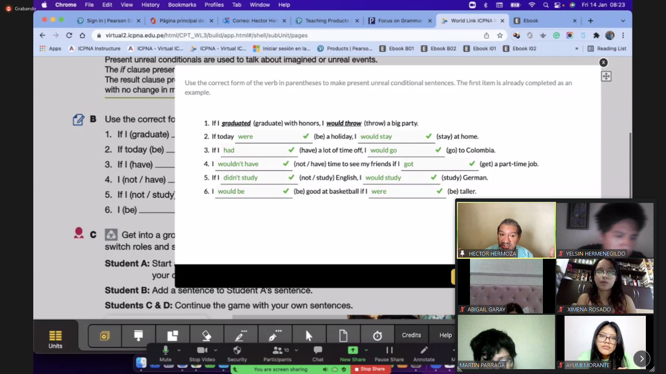

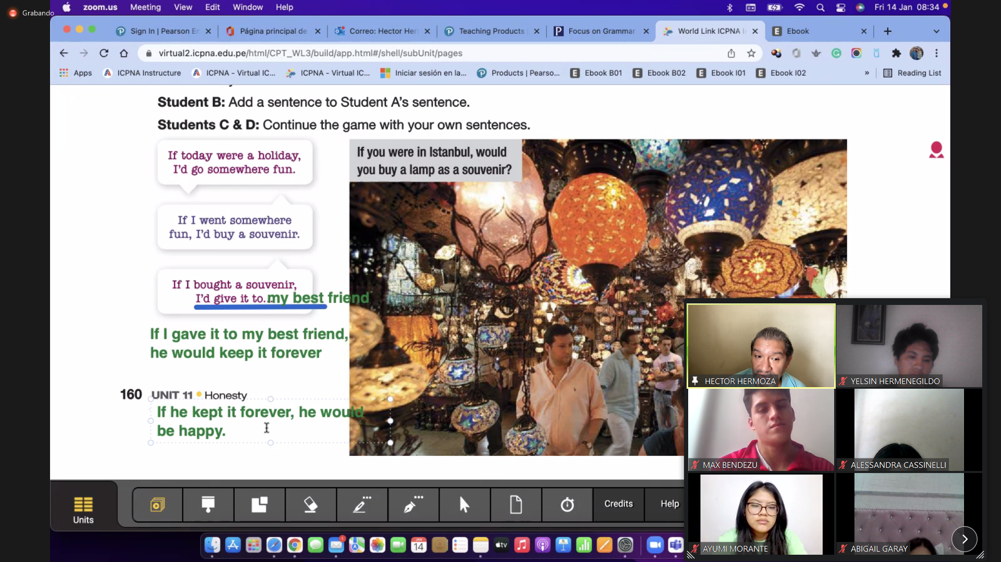

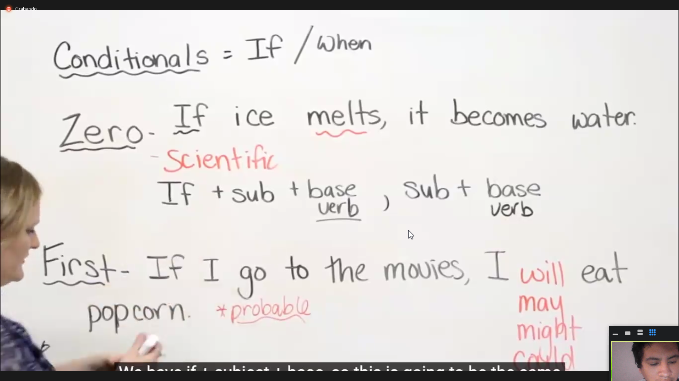

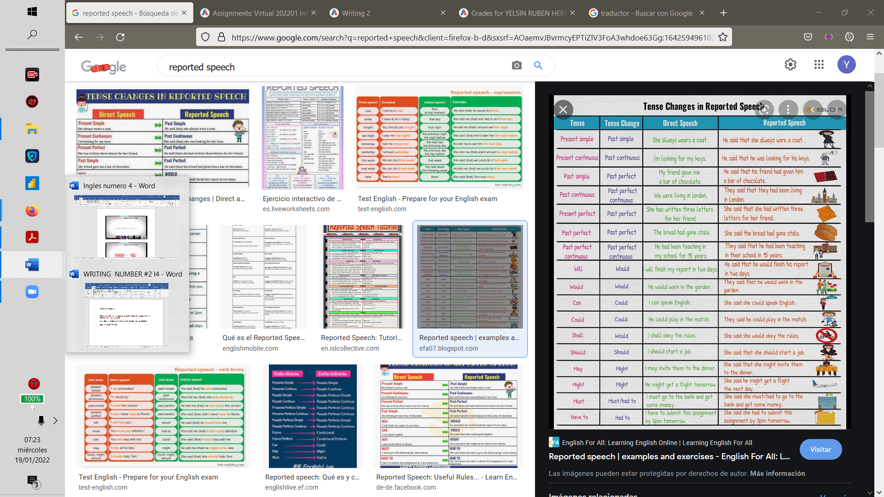

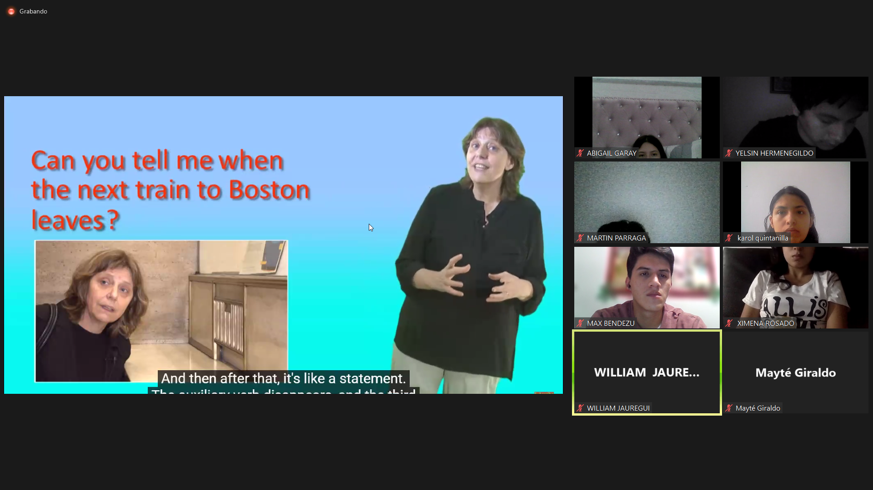

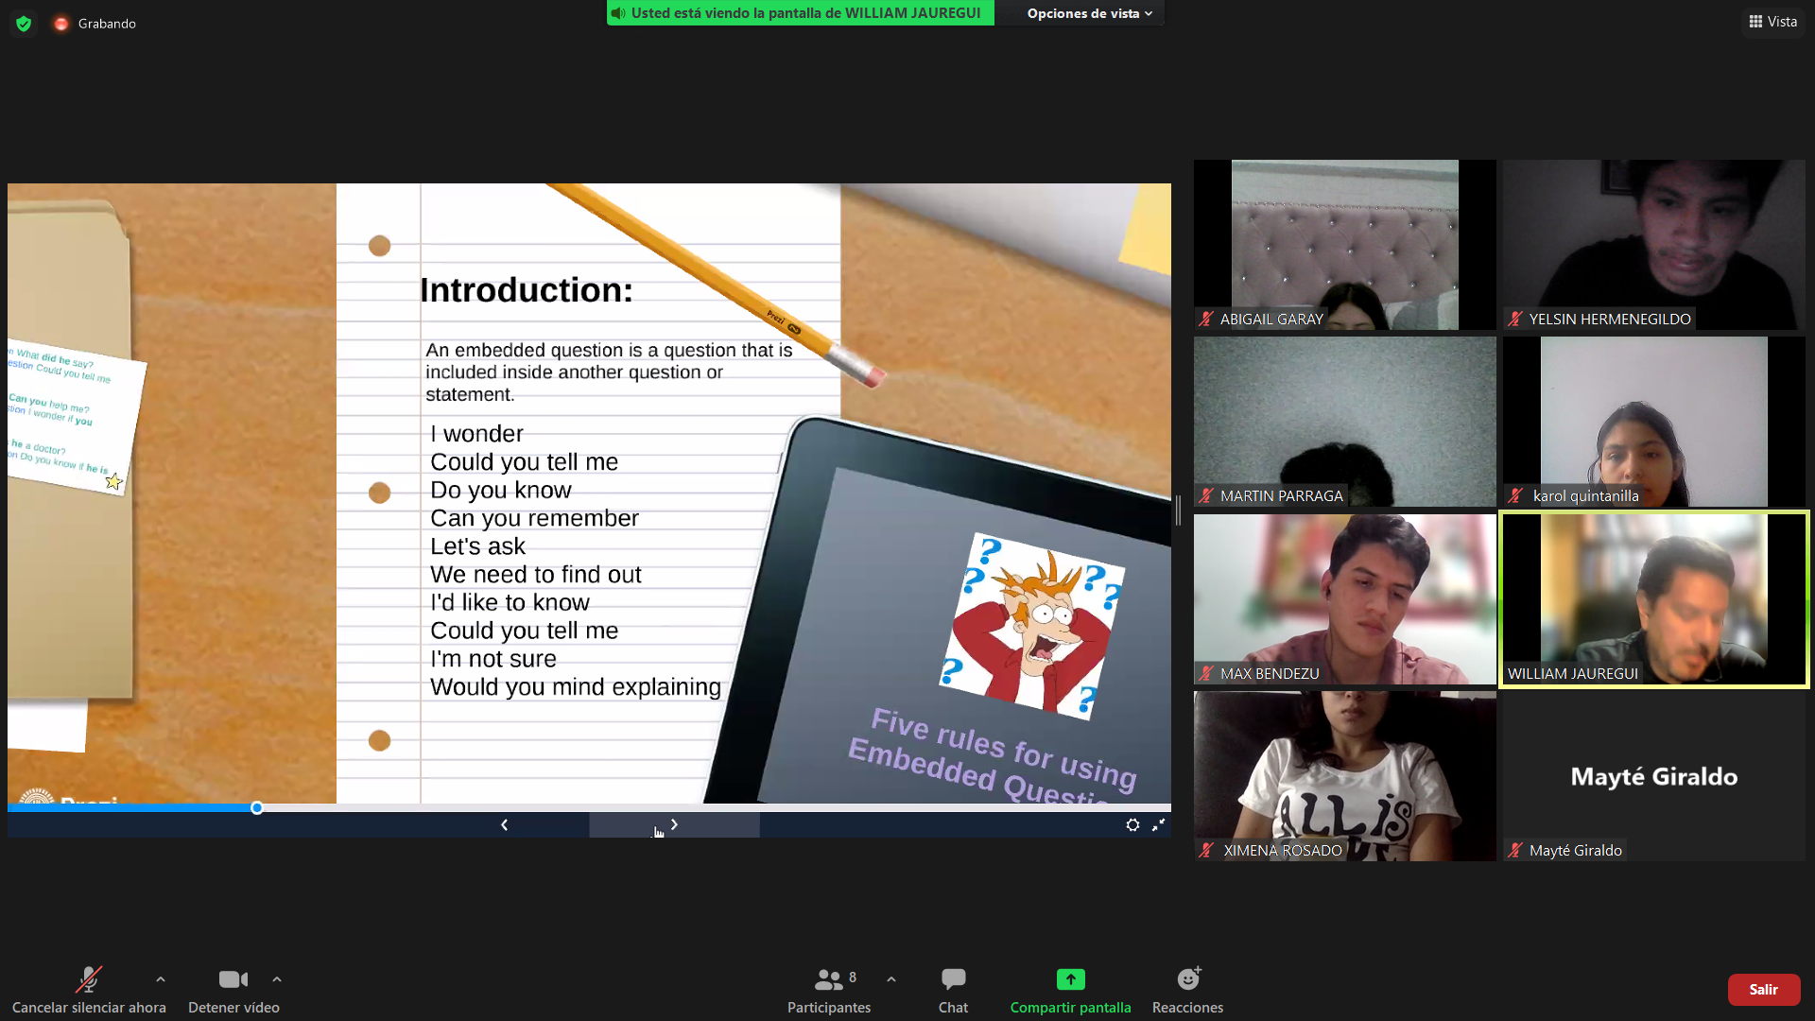

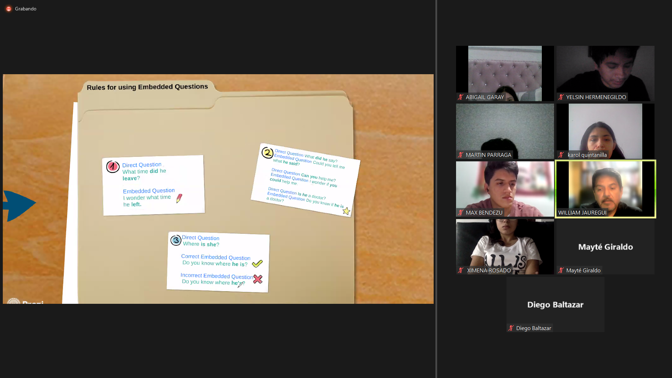

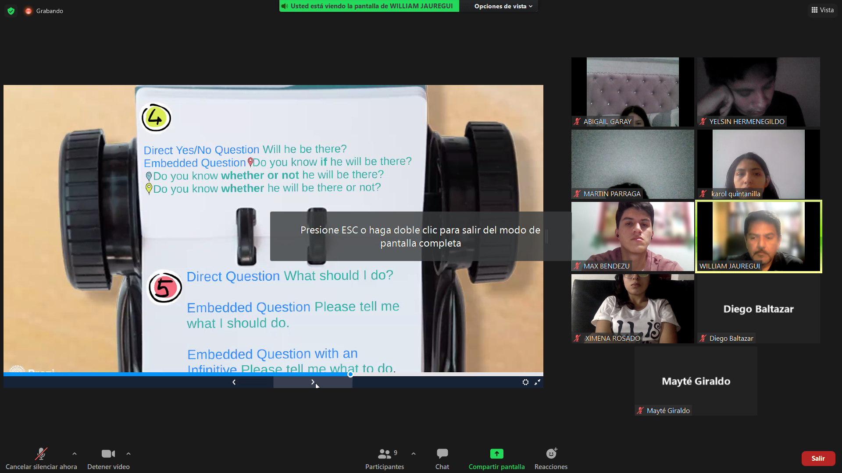

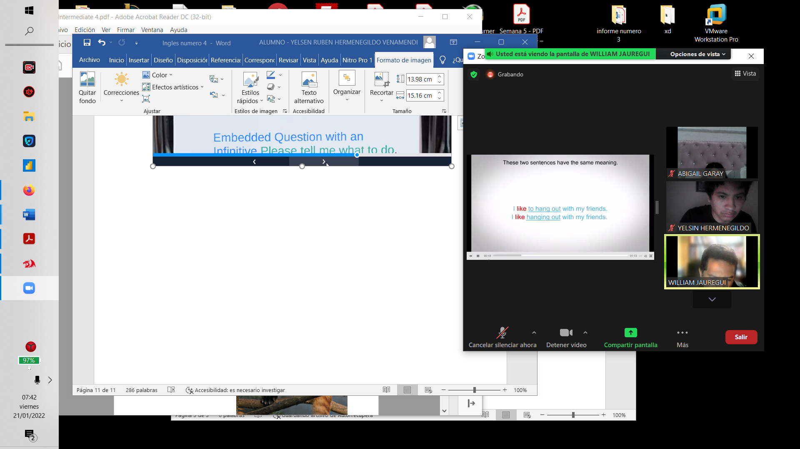

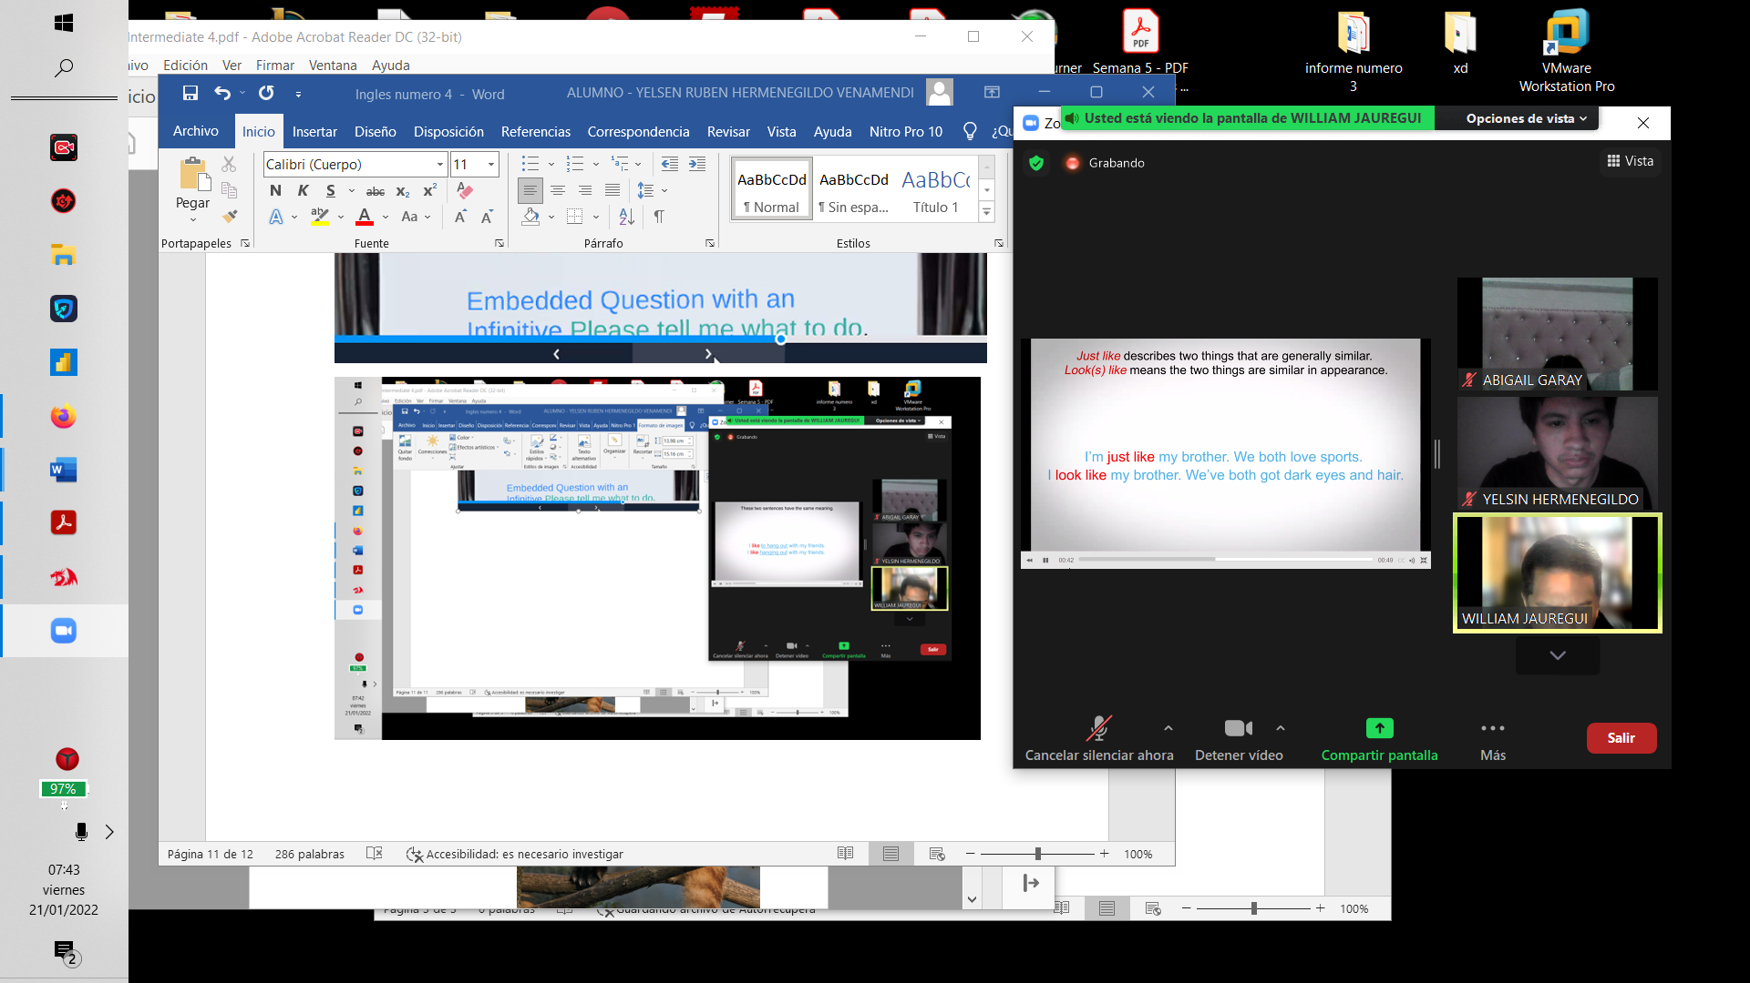

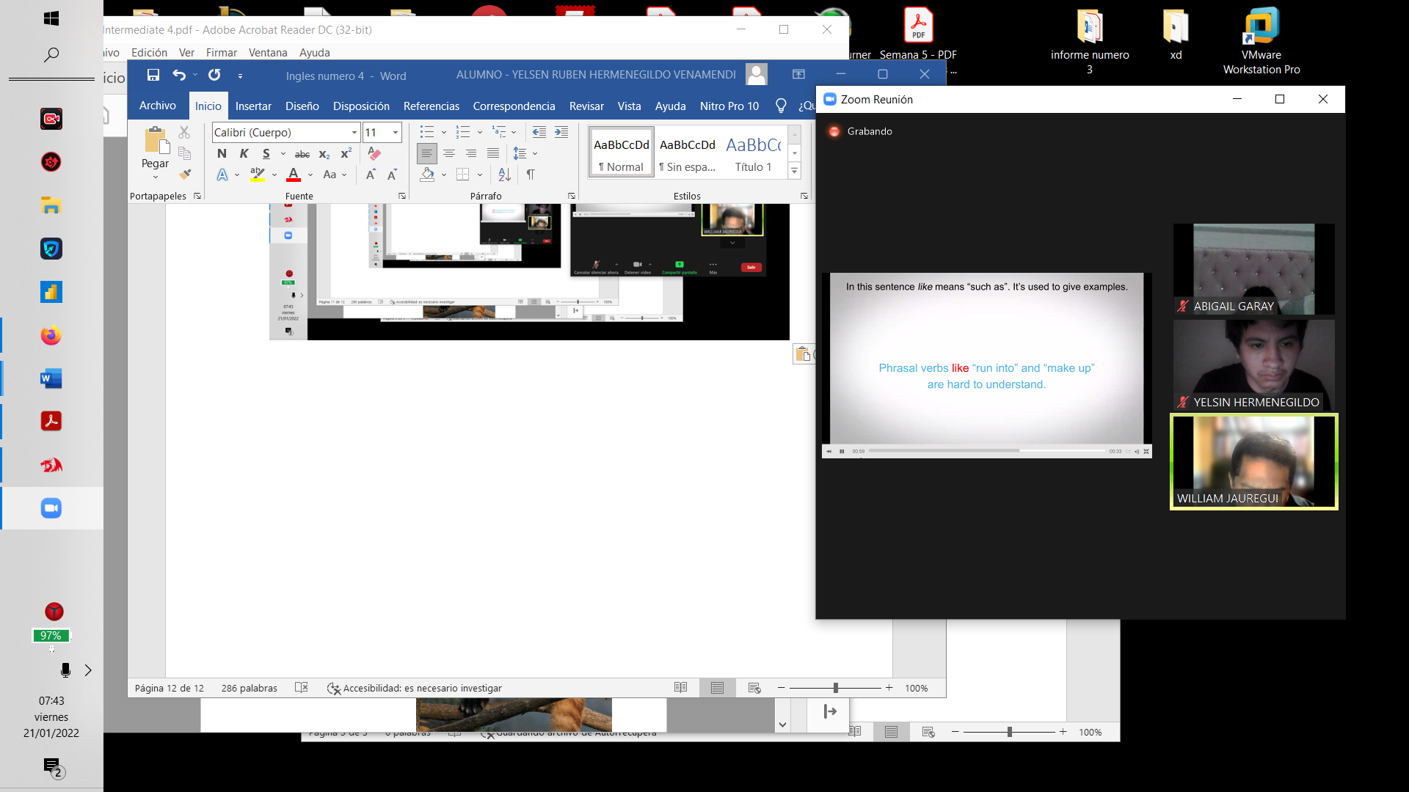

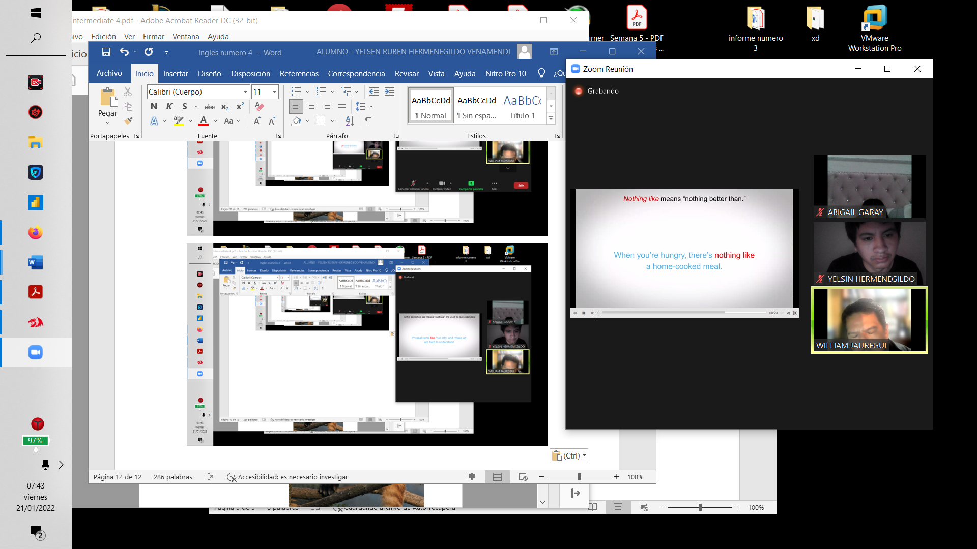

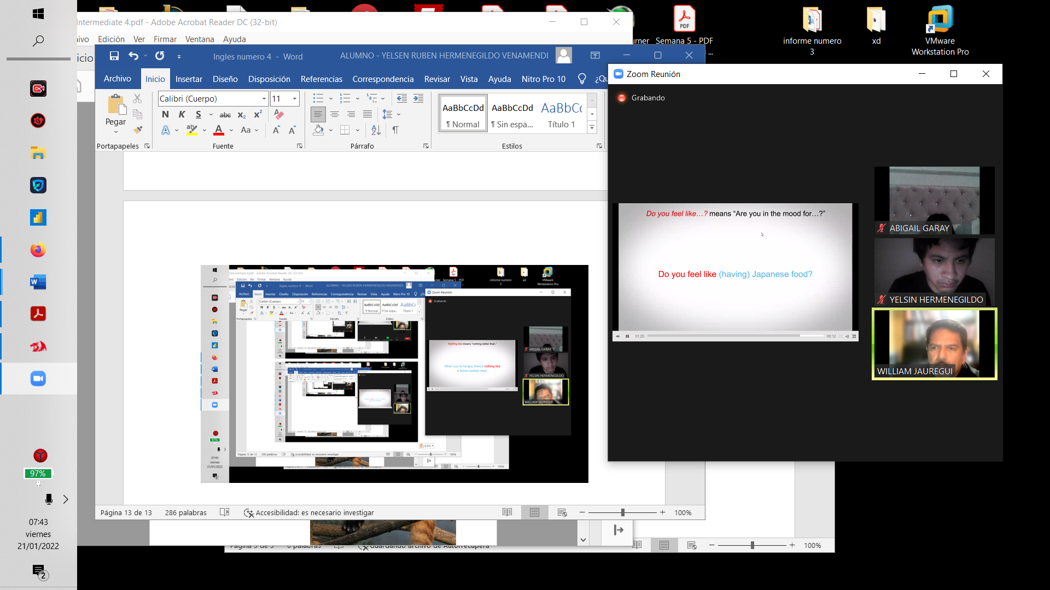

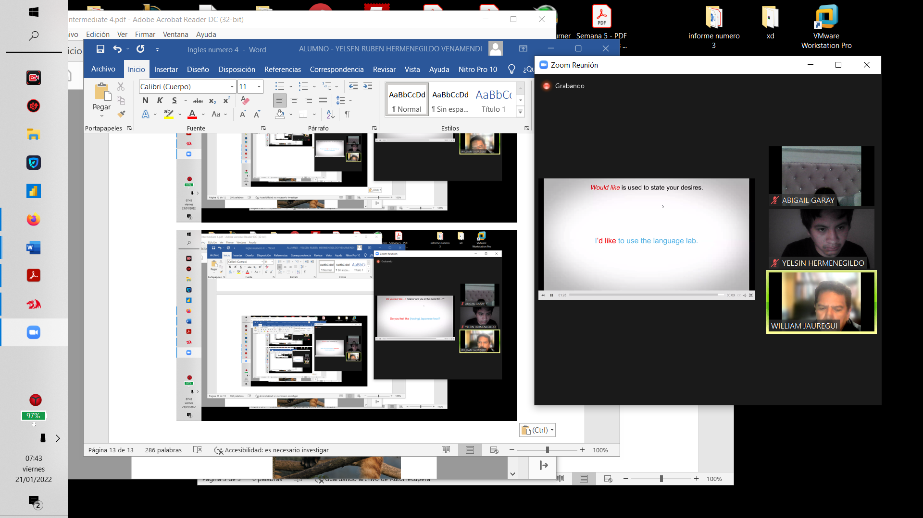

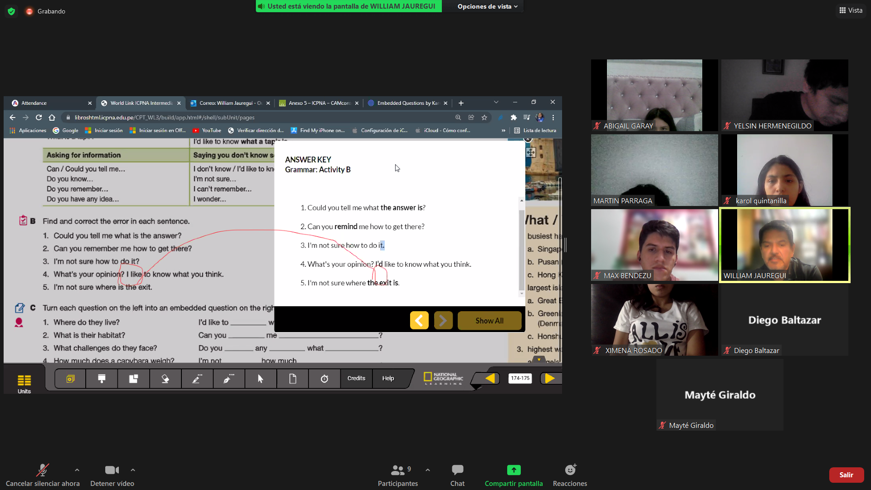

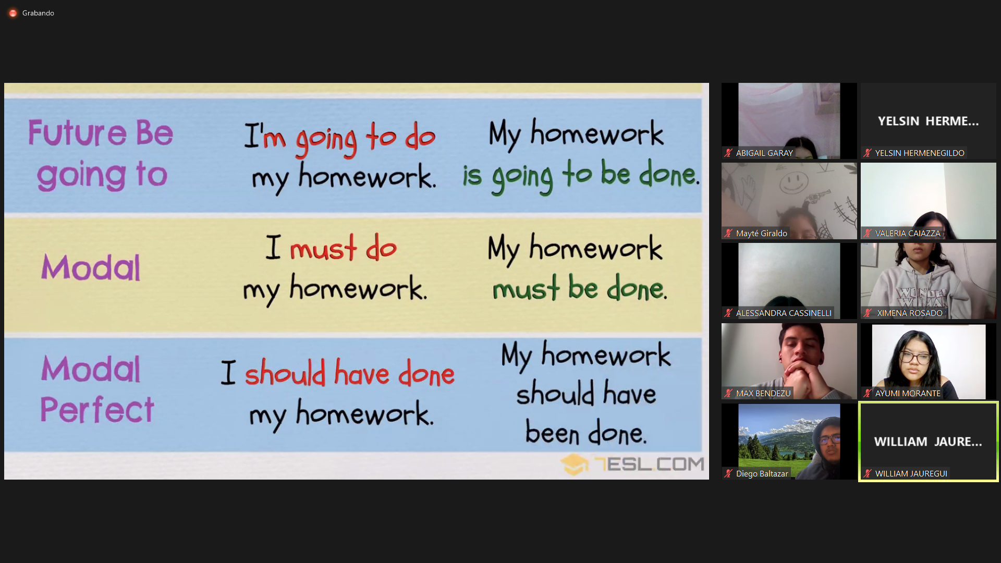

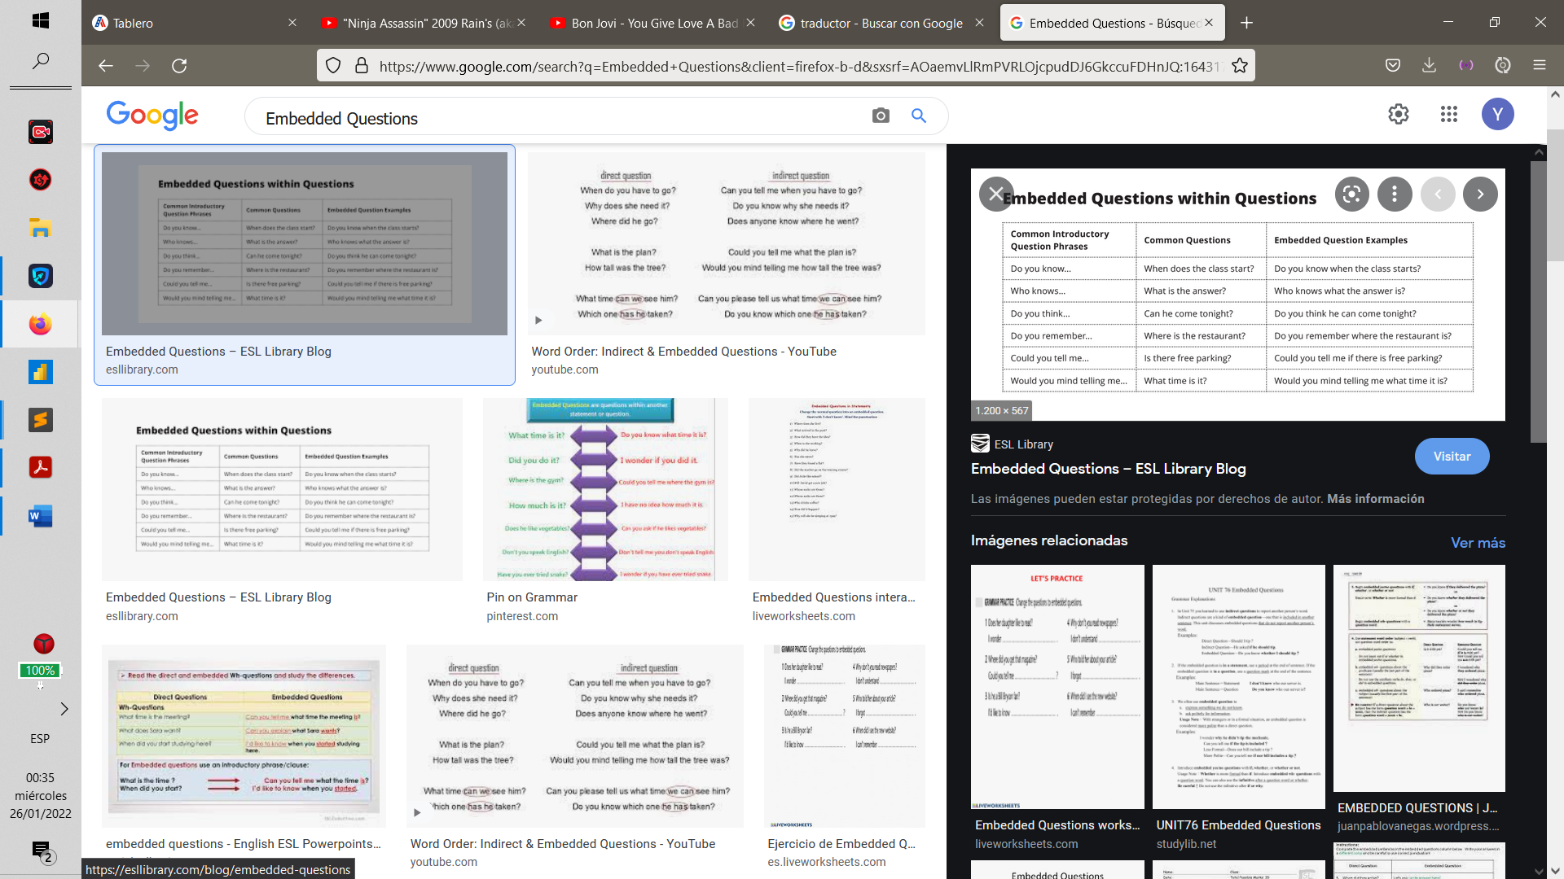

stick to / make / have a Budget ->atenerse

save ↔ spend money

borrow ↔ lend money

withstand->resistir

accommodate->

get around->llegar

Edge->borde

Leaky->agujereada

Enroded->erosionada

Squander->malgastar

Remain->permanecer

TENANTS->INQUILINOS

**Talk about the impact of values in education.**

**Integrity, honesty, punctuality and others**

**How can we integrate them in schools???**

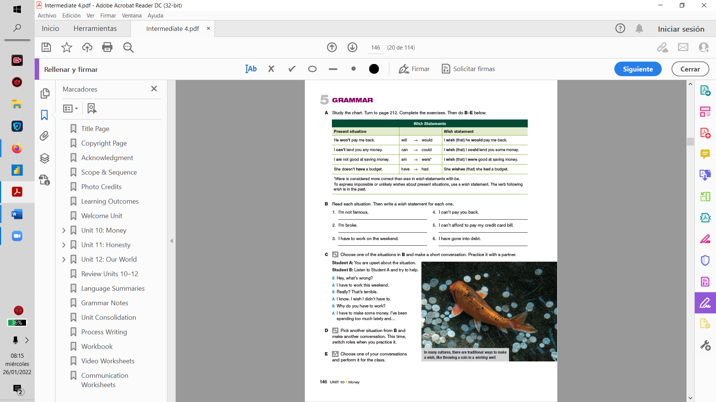

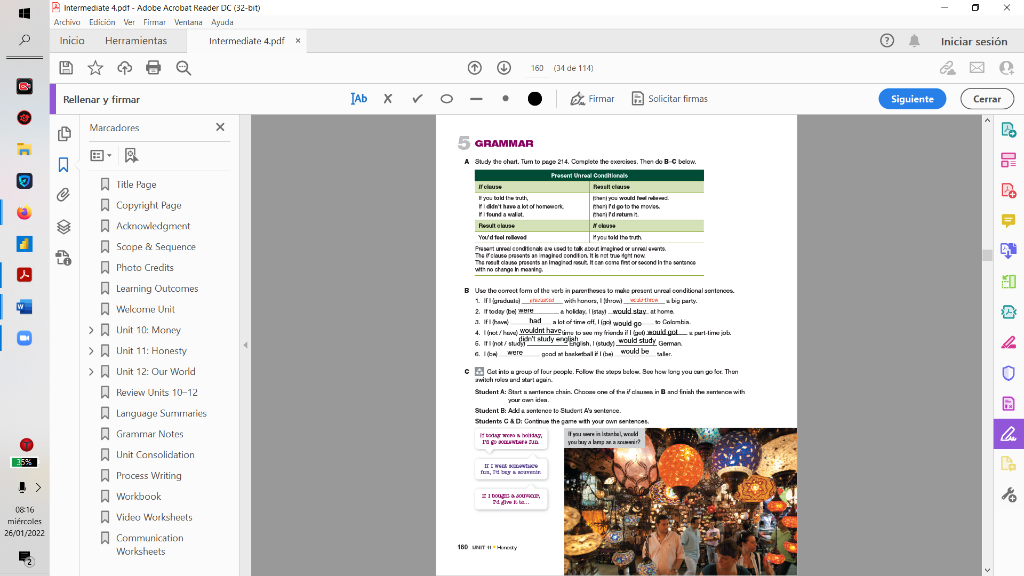

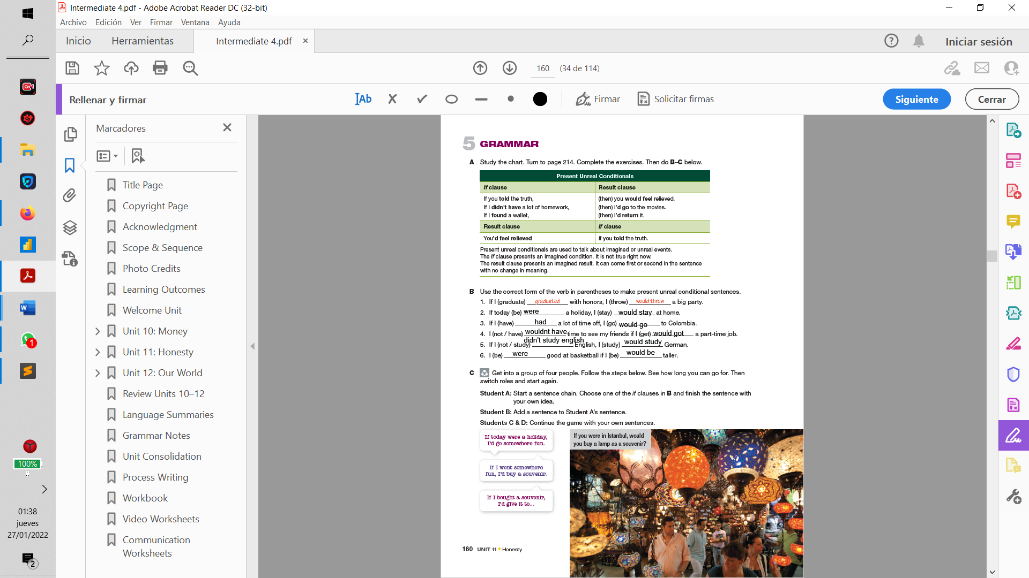

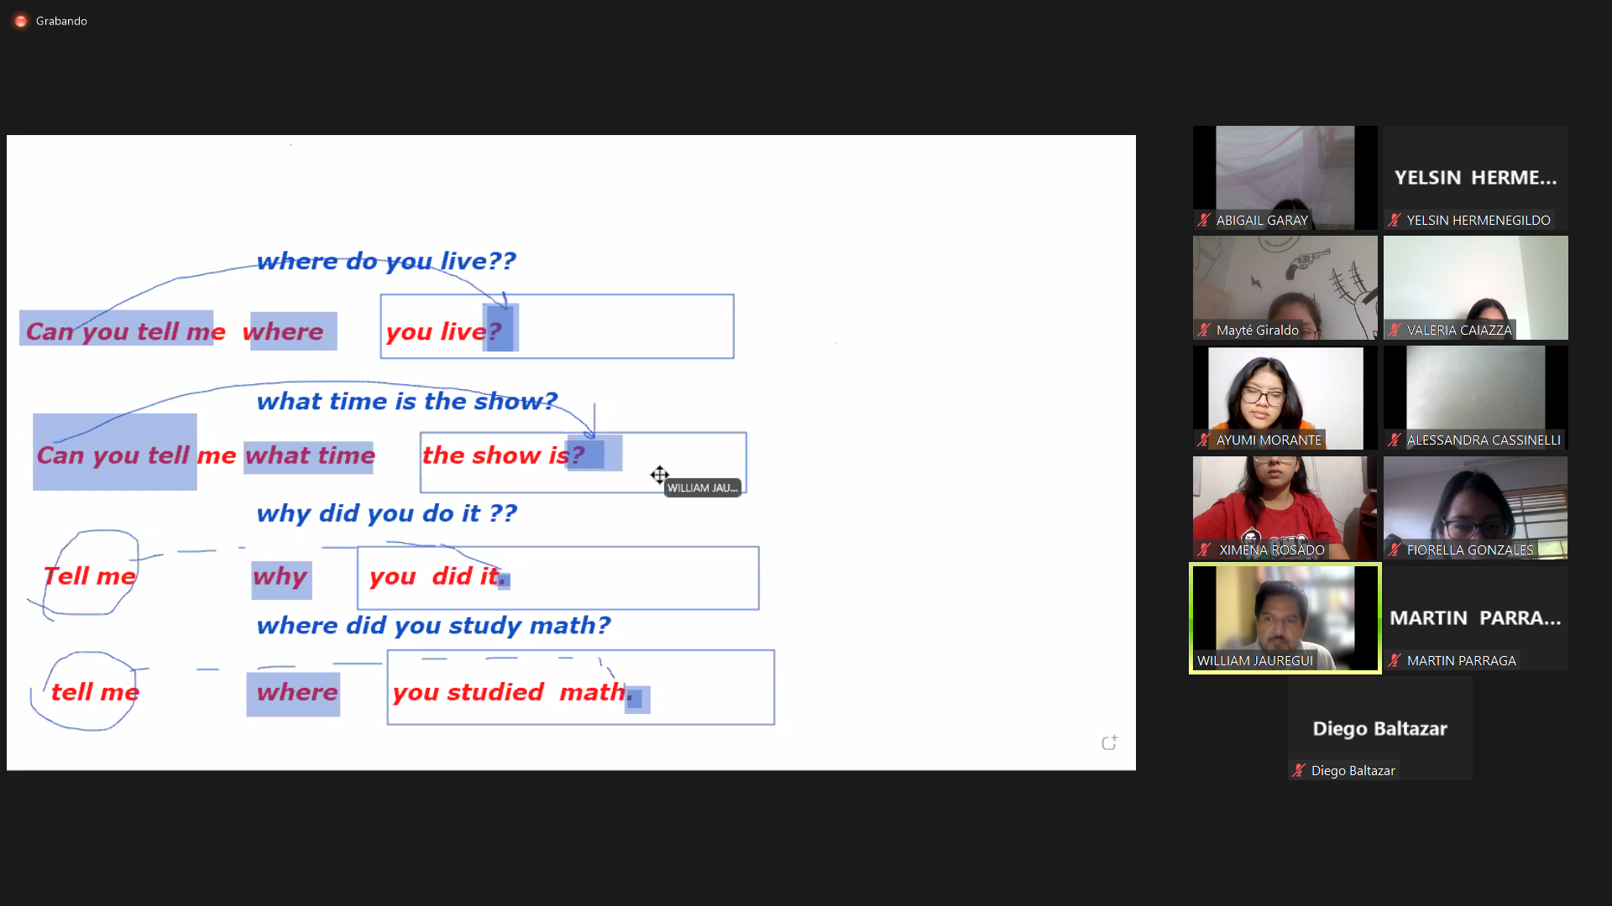

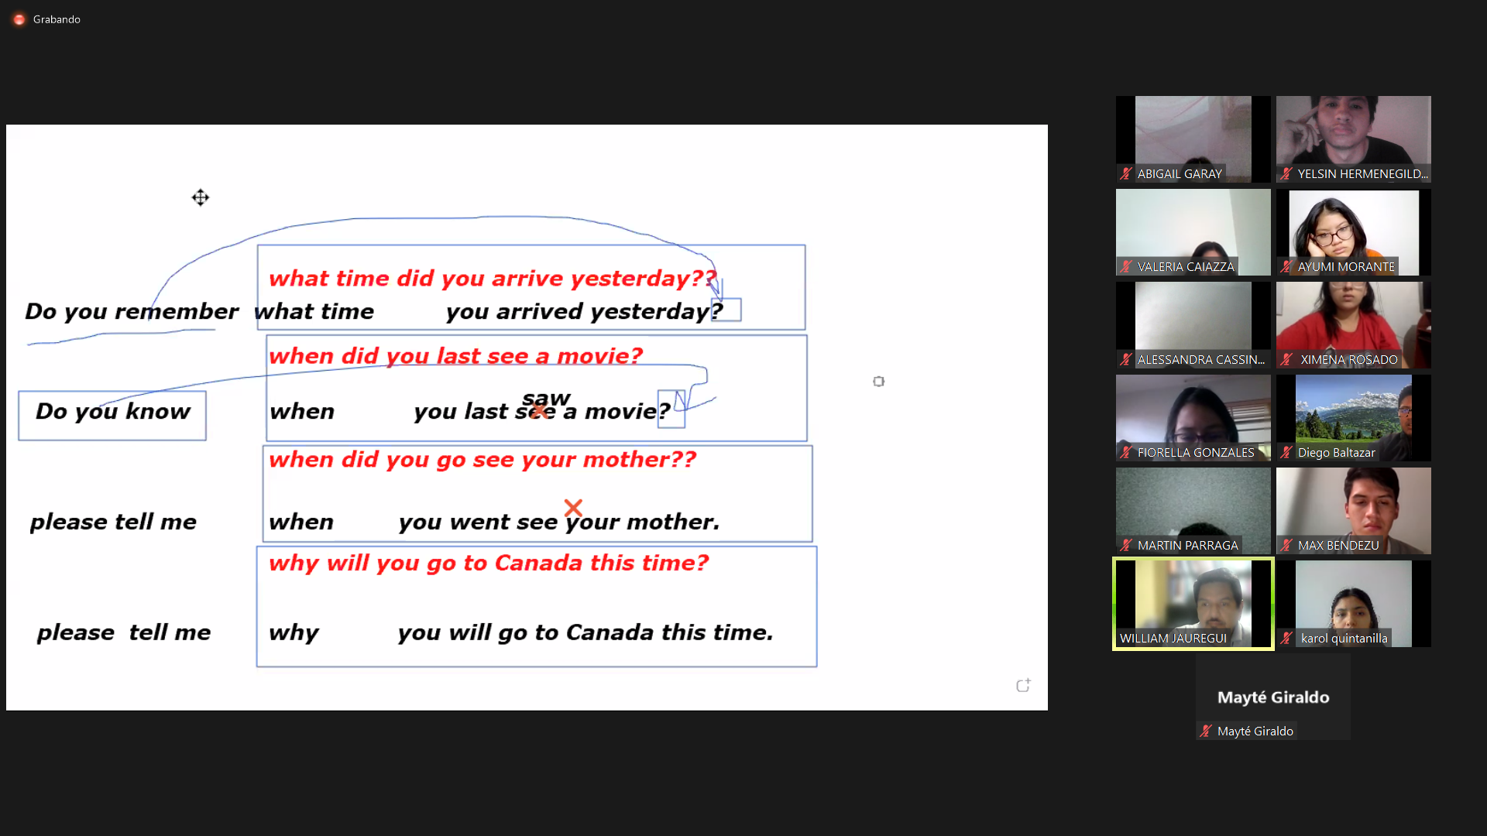

Tell me how often you play wiith your children

Can you tell me when you Will play me back.

Whrere she went with you this time.

